Getting access to windows by exploiting windows 7 vulnerabilities through Metasploit on Kali.

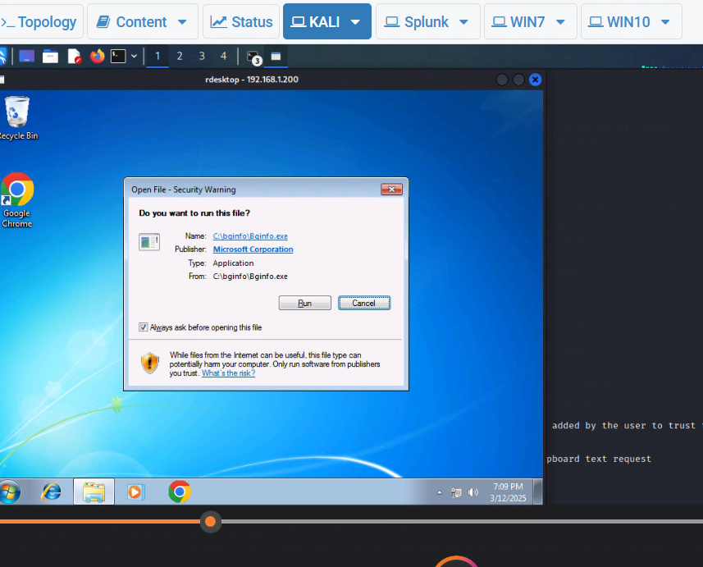



Getting Alerts on Splunk

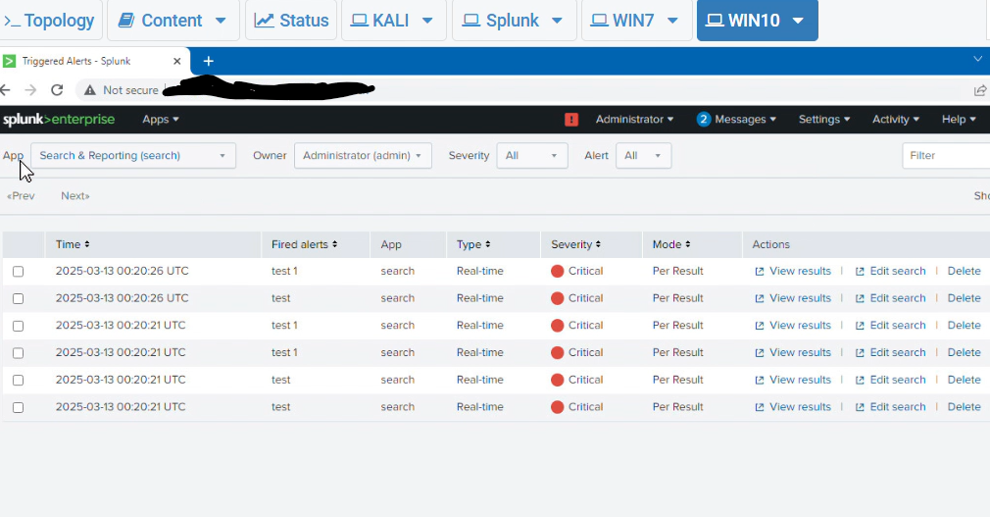

When it shows after patching and updating OS and configuring firewalls that target is not vulnerable

